INSTRUCTIONS
CLASS: TJA 8/1 | DATE: 16 March 2020

1 SB/ 58, ex 1
Listen to the recording (29 Track 29) and complete the list with the words in the books. Check the answers (exercise 1) below.
Copy the tables (times / numbers) into your notebook. Title: TIME AND NUMBERS
2 Go to British Council, link: https://learnenglishteens.britishcouncil.org/skills/listening/beginner-a1-listening/understanding-numbers
Do the exercises more than once if necessary. (Check your understanding: reordering and grouping)
3 SB/58, ex 3, 4 (recording 31 Track 31), 5
4 Send an e-mail with the answers for exercise 3 and 5
SB/58, ex 3
1) There are… bedrooms in our house.
2)
3)
4)
5)

SB/58, ex 5
1) My date of birth is ….
2)
3)
4)
5)
6)
7)

Name and surname:

HOMEWORK (HA, HA…): WB/ 48, ex 1 - 3 You get answers by Thursday (take a picture of your work and you get the answers.).
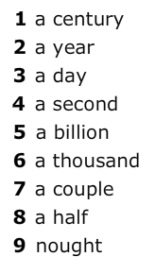
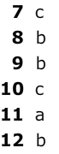
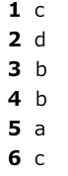
1) 3)

